Name: Chaitali Raut.
Power BI charts.
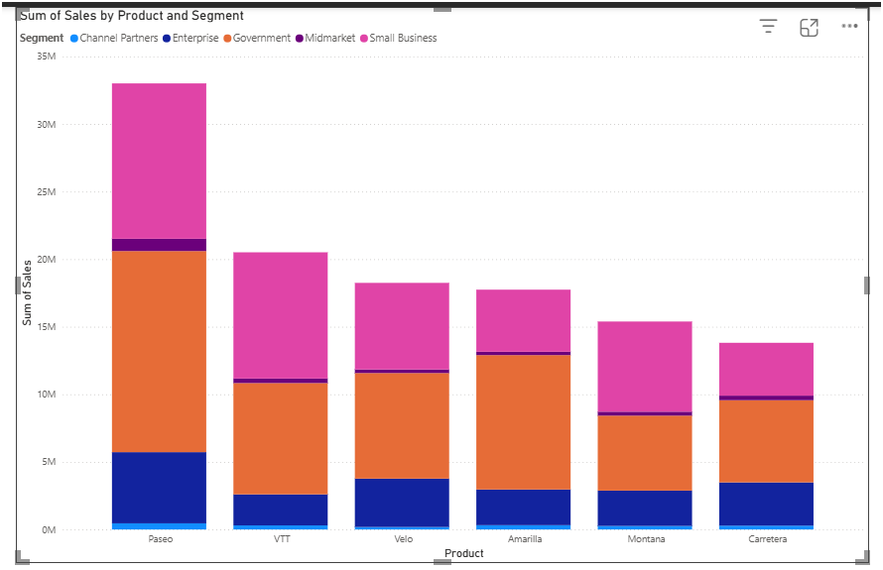

Storyline:
This chart compares the total sales of each product and shows how those sales are split across different customer segments.
Key Insights:
- Paseo shows the highest overall sales among all products.
- Government and Small Business segments form the largest portions of the stacked columns.
- Midmarket and Channel Partners contribute very small portions to total sales.
- Sales distribution is heavily concentrated in a few major segments rather than evenly spread.

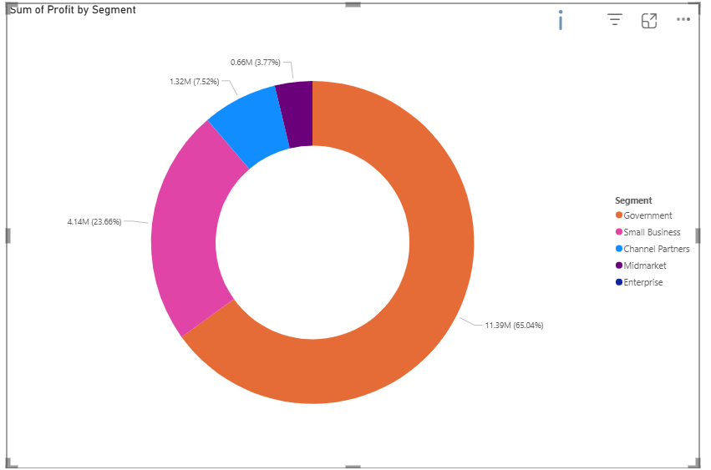
Storyline:
This chart shows the contribution of each segment to total profit.
Key Insights:
- Government generates the highest profit.
- Small Business has high sales but relatively low profit.
- Enterprise shows near-zero or low profit.
- Midmarket and Channel Partners contribute minimal profit.

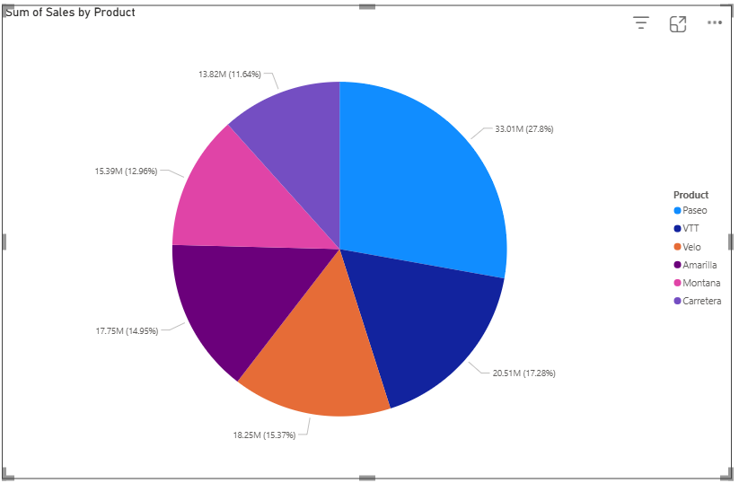
Storyline:
This chart shows which products contribute most to total sales.
Key Insights:
- Paseo holds the largest share.
- VTT and Velo are mid-range contributors.
- Amarilla and Montana contribute smaller portions.

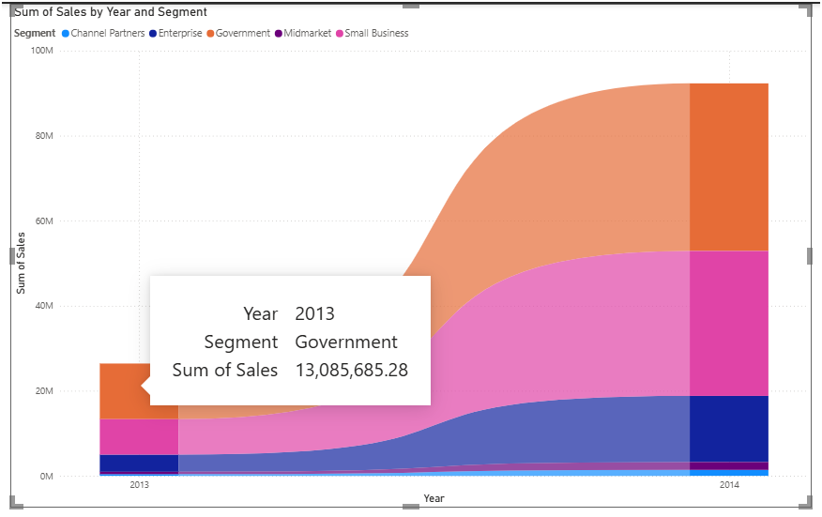

Storyline:
This chart shows how segment ranking changes over time based on sales.
Key Insights:
- Government segment consistently ranks first.
- Small Business remains second in most years.

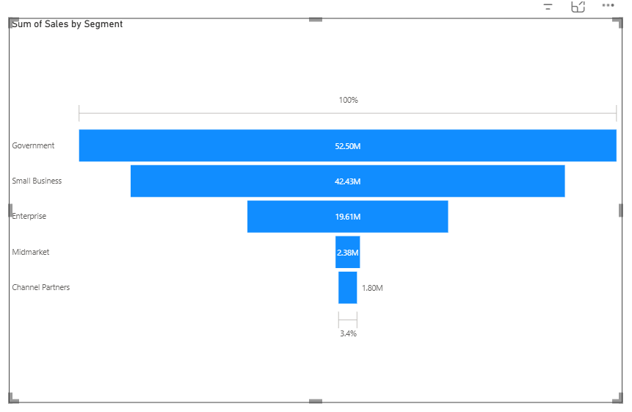
Storyline:
This chart shows how sales volume decreases across different customer segments.
Key Insights:
- Government segment is at the top of the funnel.
- Small Business follows closely.
- Enterprise and others form the lower end of the funnel.

